**Python Lab Practicals**

Name : Chetan Lohani Course : MCA(A)

Section:A Roll No.:2001050

1 Write a program to use the Mathematical operators.

a=3  
b=4  
c=a+b  
print(c)  
a=7  
b=3  
c=a-b  
print(c)  
a=3  
b=4  
c=a*b  
print(c)  
a=6  
b=2  
c=a/b  
print(c)  
a=7  
b=2  
c=a%b  
print(c)

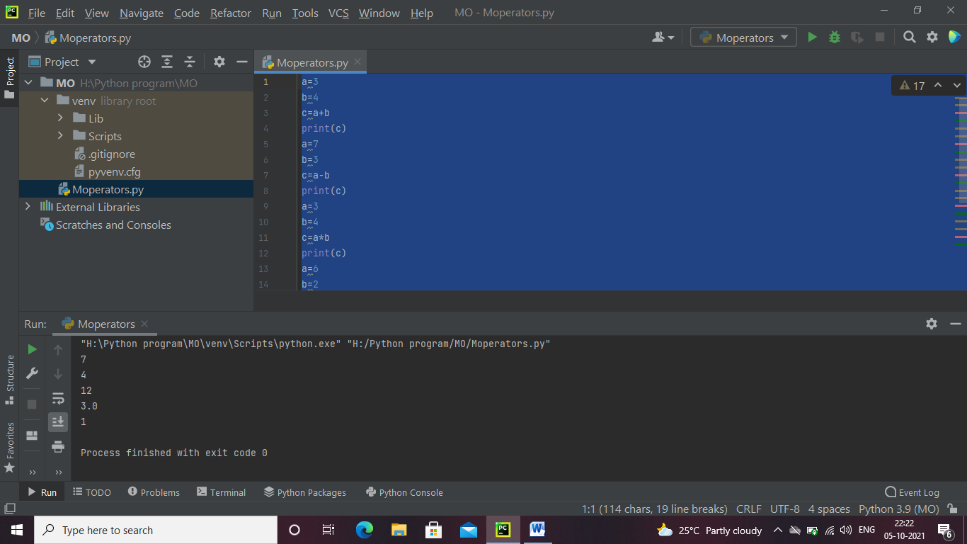

2 write a program to take an input of numbers from the user and print the Fibonacci series to the terminal number.

num = int(input("Enter any number: "))  
n1,n2 = 0,1  
sum = 0  
if num<=0:  
 print('Please enter number greater than 0')  
else:  
 for i in range(0,num):  
 print(sum,end=" ")  
 n1=n2  
 n2=sum  
 sum=n1+n2

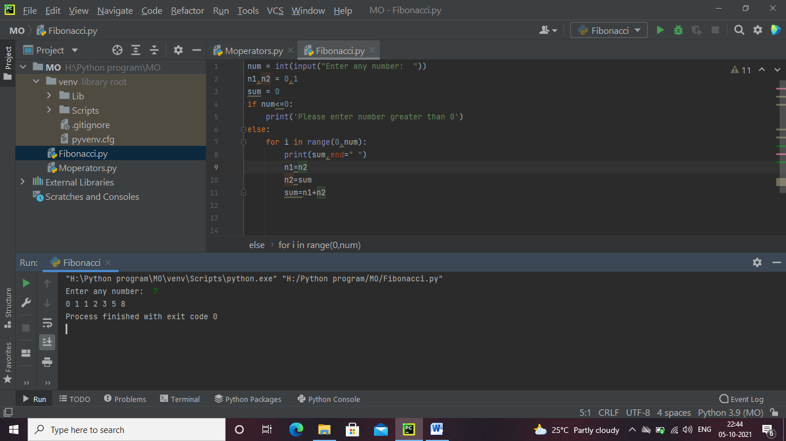

**3.Write a program to print the factorial of the number input by the user.**

# Python program to find the factorial of a number provided by the user.  
  
  
  
# To take input from the user  
num = int(input("Enter a number: "))  
  
factorial = 1  
  
# check if the number is negative, positive or zero  
if num < 0:  
 print("Sorry, factorial does not exist for negative numbers")  
elif num == 0:  
 print("The factorial of 0 is 1")  
else:  
 for i in range(1,num + 1):  
 factorial = factorial*i  
 print("The factorial of",num,"is",factorial)

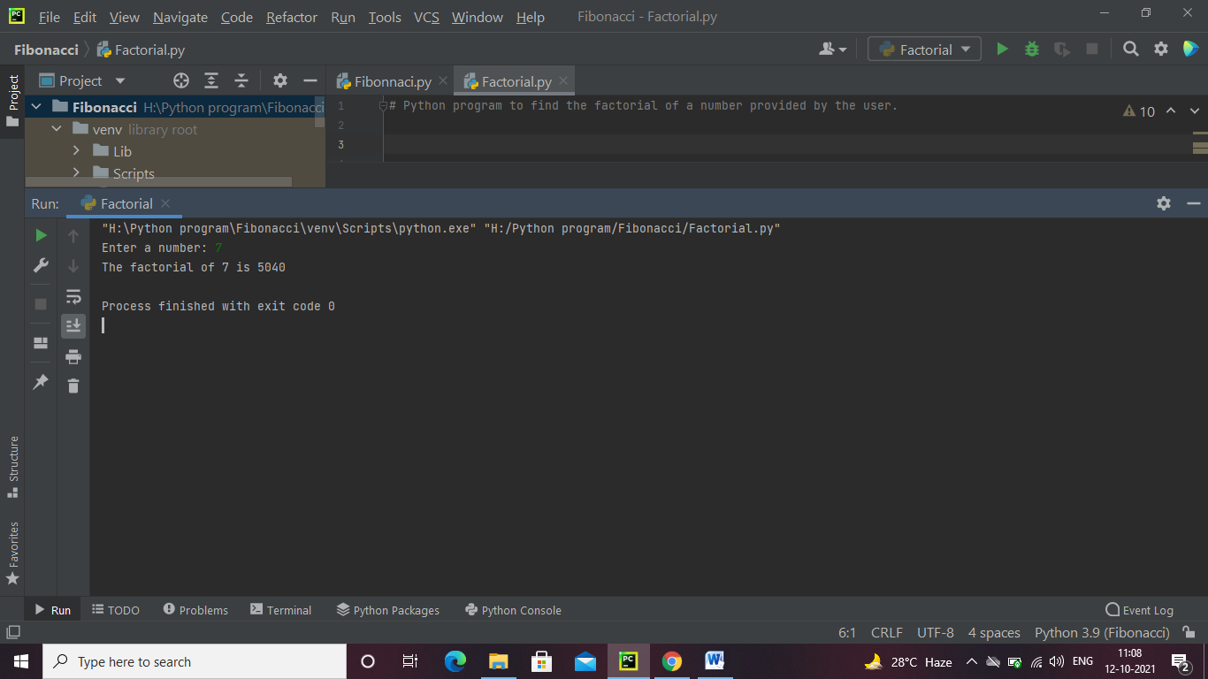

**4. Write a program to check whether a given number is a prime number or not using loops.**

num = int(input("enter a number:-"))  
if num > 1:  
 # check for factors  
 for i in range(2, num):  
 if (num % i) == 0:  
 print(num, "is not a prime number")  
 print(i, "times", num // i, "is", num)  
 break  
 else:  
 print(num, "is a prime number")  
else:  
 print(num, "is not a prime number")

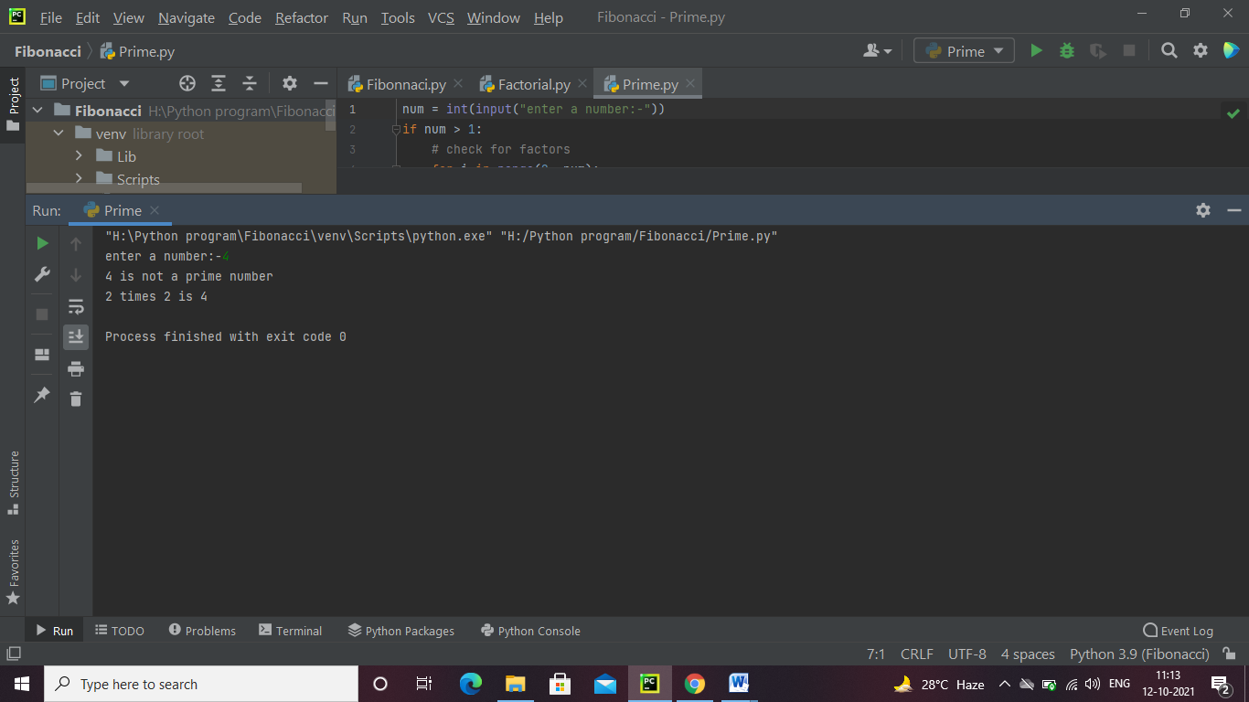

**5.Write a program to demonstrate the importing of modules of python.**

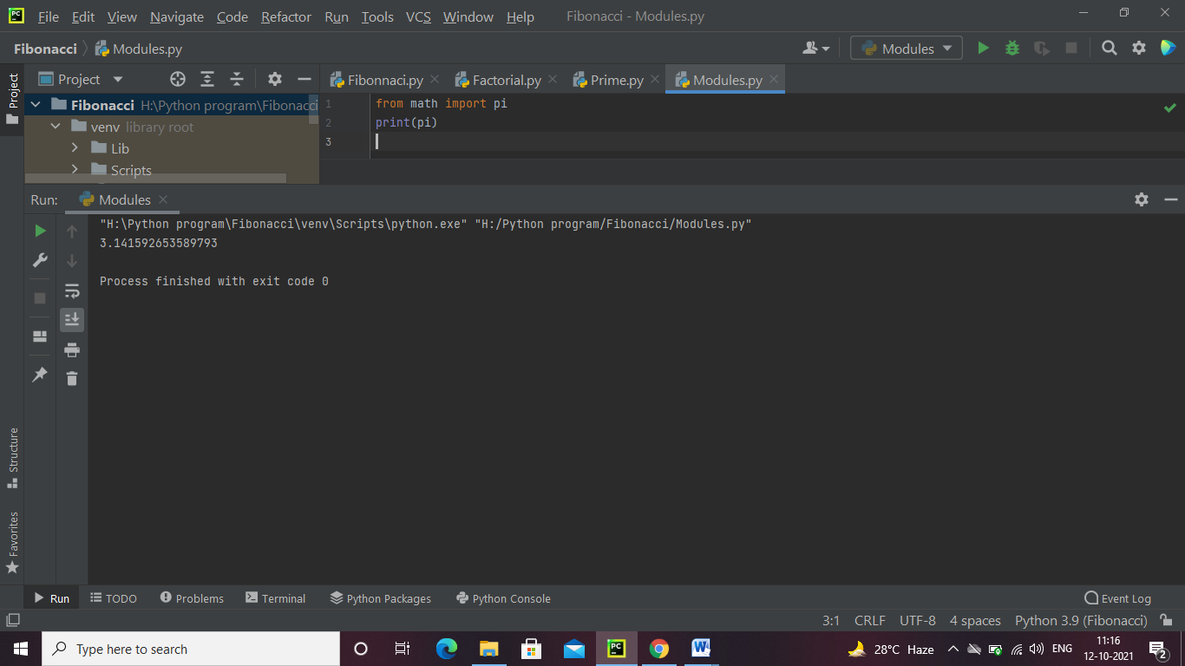

**6. Write a program to demonstrate the use of nested if statements.**

num =int(input("enter a number:-"))  
if num >= 0:  
 if num == 0:  
 print("Zero")  
 else:  
 print("Positive number")  
else:  
 print("Negative number")

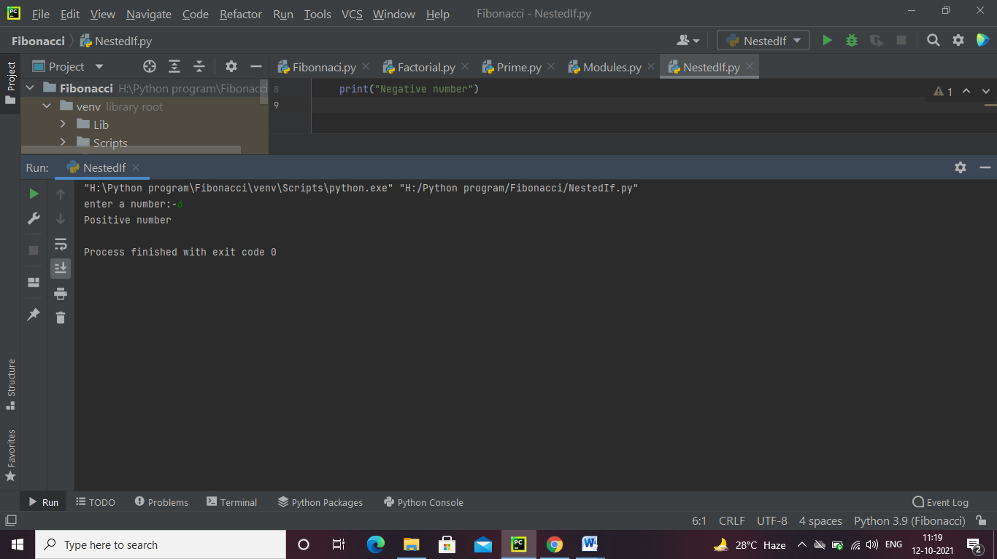

**7. Write a program to demonstrate the use of the else clause.**

num =int(input("enter a number:-"))  
if num >0:  
  
 print("Positive number")  
else:  
 print("Negative number")

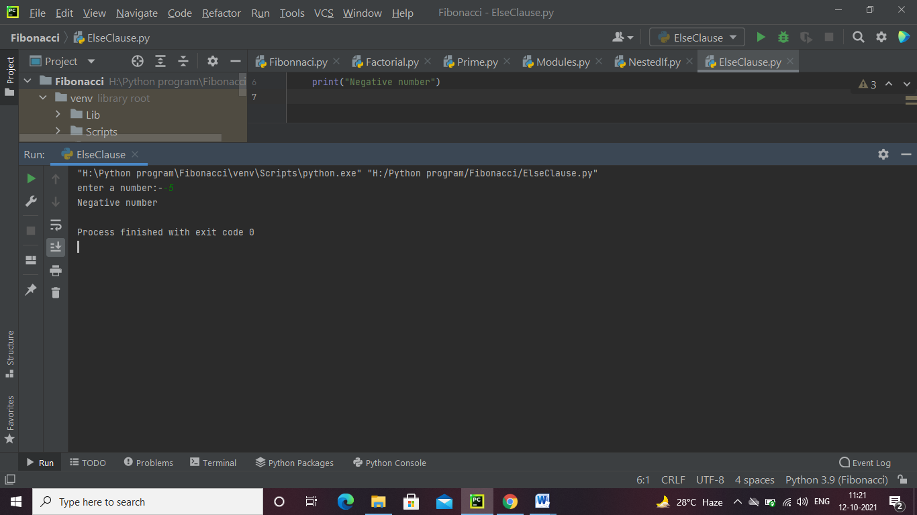

**8. Write a program to illustrate the usage of Tuples.**

thistuple = ("apple", "vinod", "chetan")  
print(thistuple)

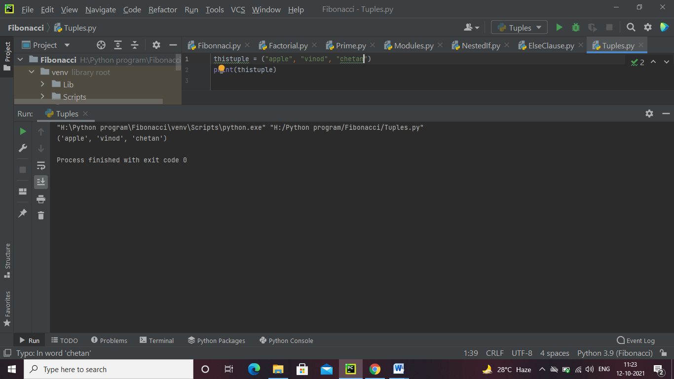

**9.Write a program for searching an element and sorting a List.**

my_list = [4,3, 2, 1]  
my_list.sort()  
print(my_list)  
n=int(input("enter the element to be searched:-"))  
print("element found at index:-",my_list.index(n))

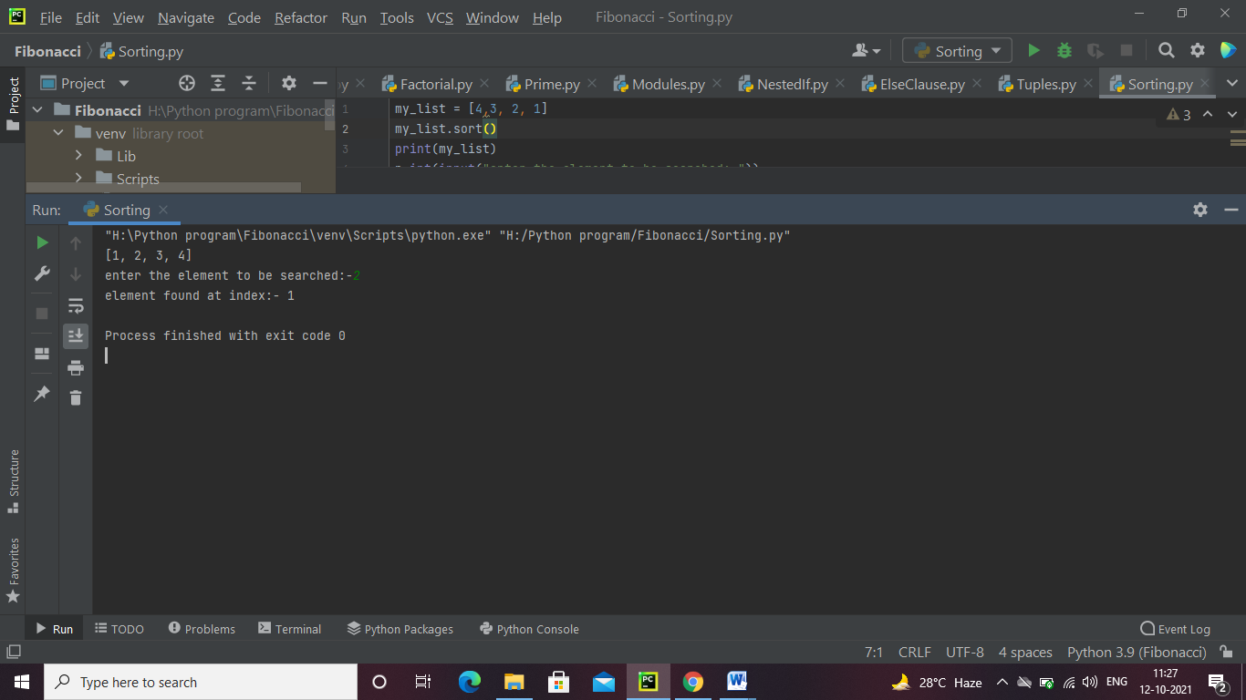

**10. Write a program to illustrate the usage of Dictionaries.**

my_dict = {'name': 'chetan', 'age': 26}  
  
  
my_dict['age'] = 22  
  
print(my_dict)  
  
my_dict['address'] = 'Downtown'  
  
print(my_dict)

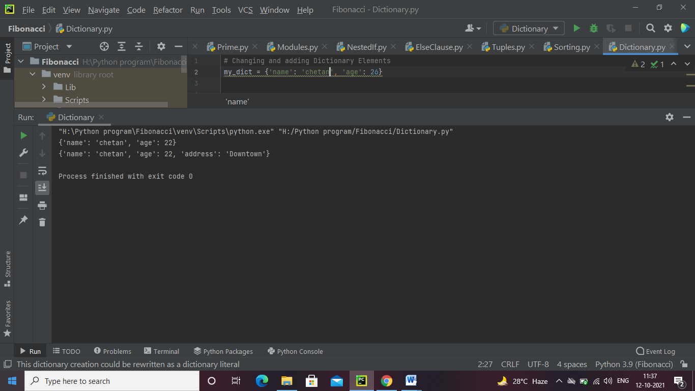

**11.Write a program to find the mean. mode and median of the given range of numbers.**

import numpy  
from scipy import stats  
speed = [99,86,87,88,111,86,90,80,94,78,77,85,86]  
x = numpy.mean(speed)  
x1 = numpy.median(speed)  
x2 = stats.mode(speed)  
print("Mean=",x)  
print("Median=",x)  
print(x2)

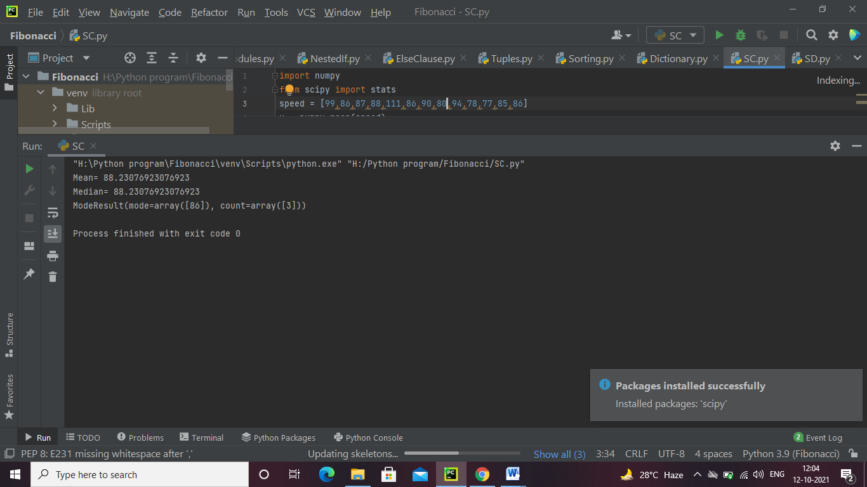

**12 Write a program to calculate the standard deviation of a given set of numbers.**

import numpy  
speed = [86,87,88,86,87,85,86]  
x = numpy.std(speed)  
print("standard deviation=",x)

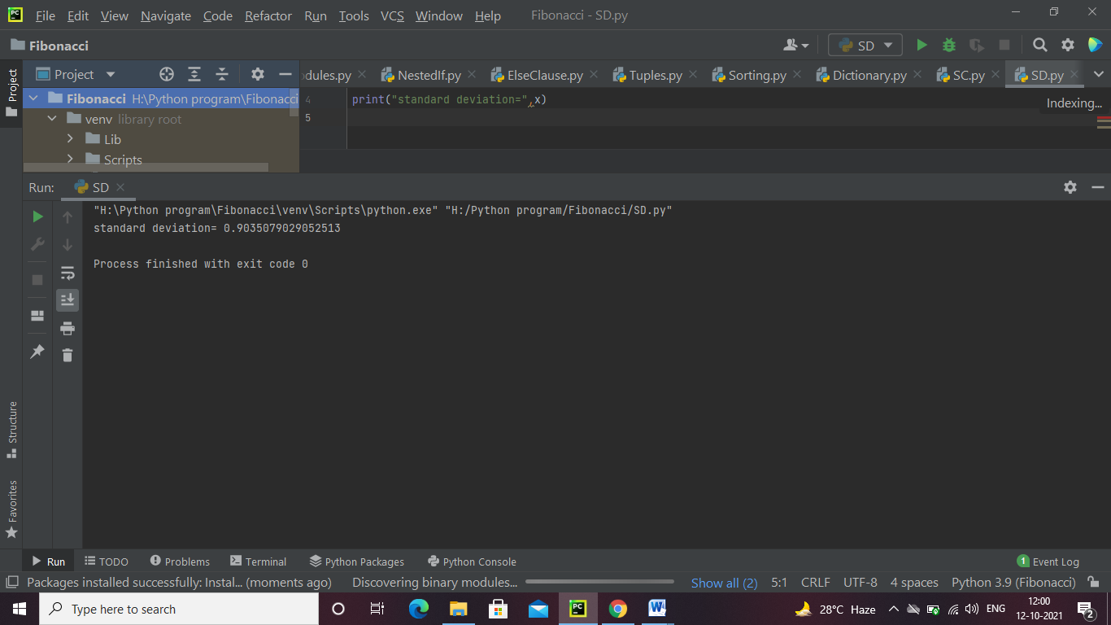

**13. Write a program to calculate the addition of two 3x 3 matrices.**

X = [[12,7,3],  
 [4 ,5,6],  
 [7 ,8,9]]  
  
Y = [[5,8,1],  
 [6,7,3],  
 [4,5,9]]  
  
result = [[0,0,0],  
 [0,0,0],  
 [0,0,0]]  
  
for i in range(len(X)):  
  
 for j in range(len(X[0])):  
 result[i][j] = X[i][j] + Y[i][j]  
  
for r in result:  
 print(r)

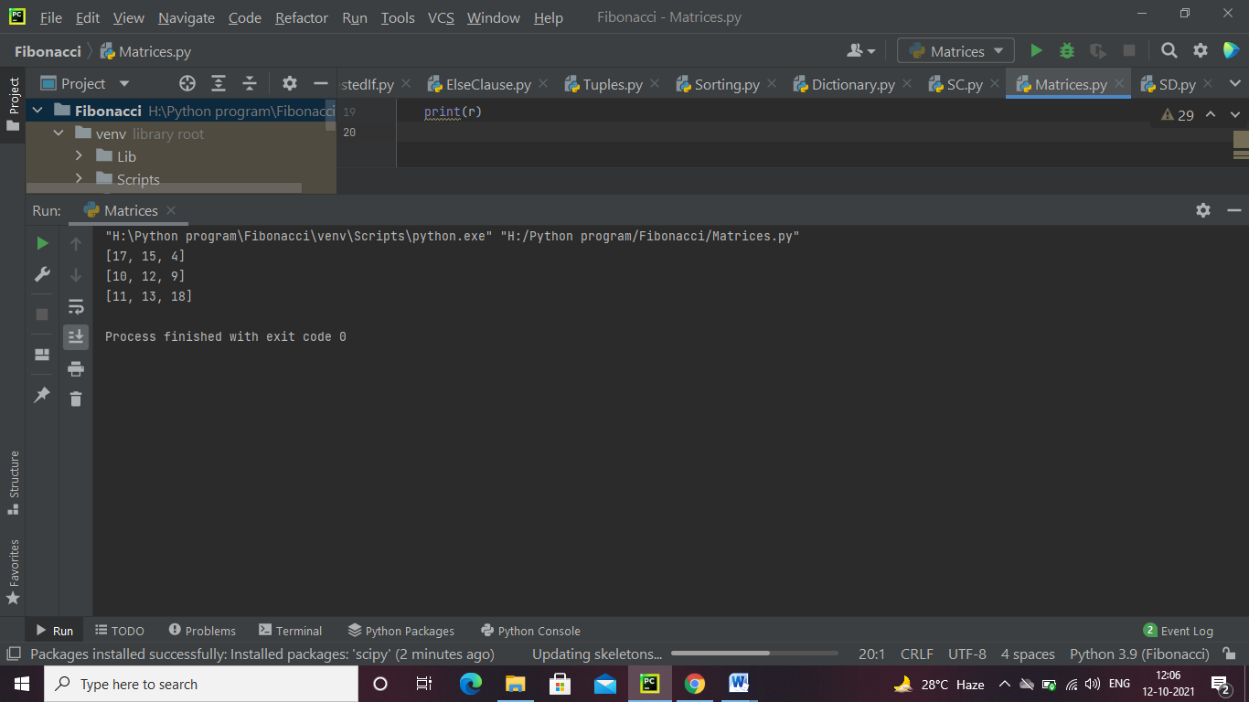

**14. Write a program to calculate the multiplication of two 3x 3 matrices.**

X = [[12, 7, 3],  
 [4, 5, 6],  
 [7, 8, 9]]  
  
Y = [[5, 8, 1, 2],  
 [6, 7, 3, 0],  
 [4, 5, 9, 1]]  
# result is 3x4  
result = [[0, 0, 0, 0],  
 [0, 0, 0, 0],  
 [0, 0, 0, 0]]  
  
for i in range(len(X)):  
  
 for j in range(len(Y[0])):  
  
 for k in range(len(Y)):  
 result[i][j] += X[i][k] * Y[k][j]  
  
for r in result:  
 print(r)

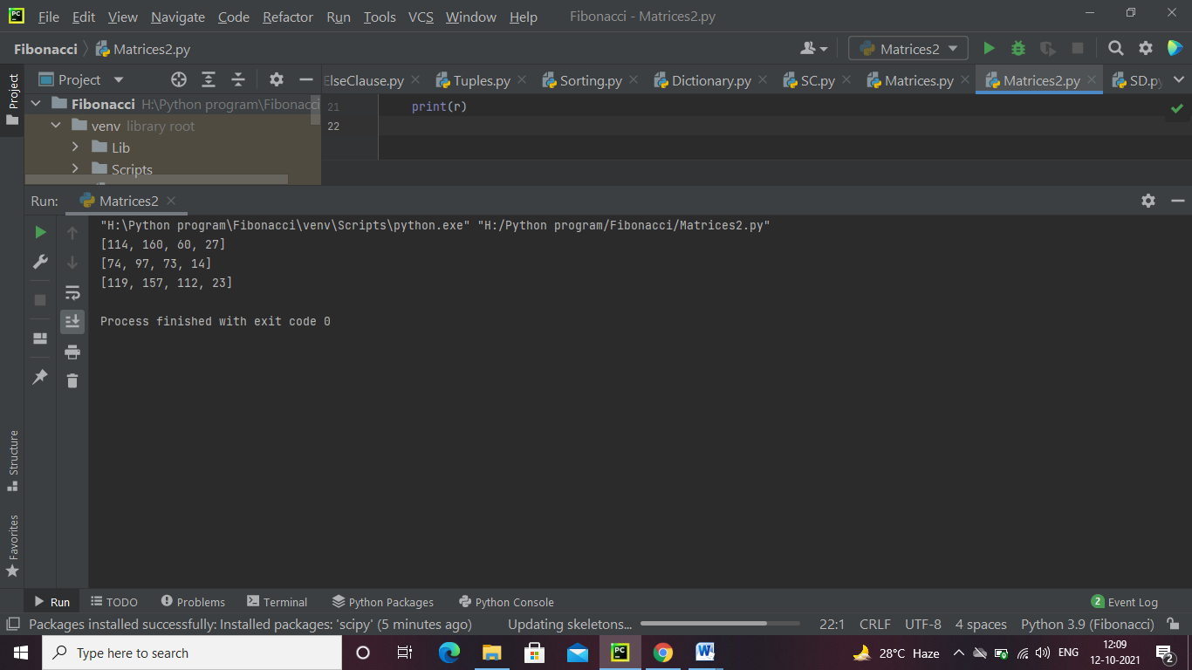

**15. Write a program to calculate the inverse of the given matrix.**

import numpy as np  
A = np.array([[6, 1, 1, 3],  
 [4, -2, 5, 1],  
 [2, 8, 7, 6],  
 [3, 1, 9, 7]])  
  
# Calculating the inverse of the matrix  
print(np.linalg.inv(A))

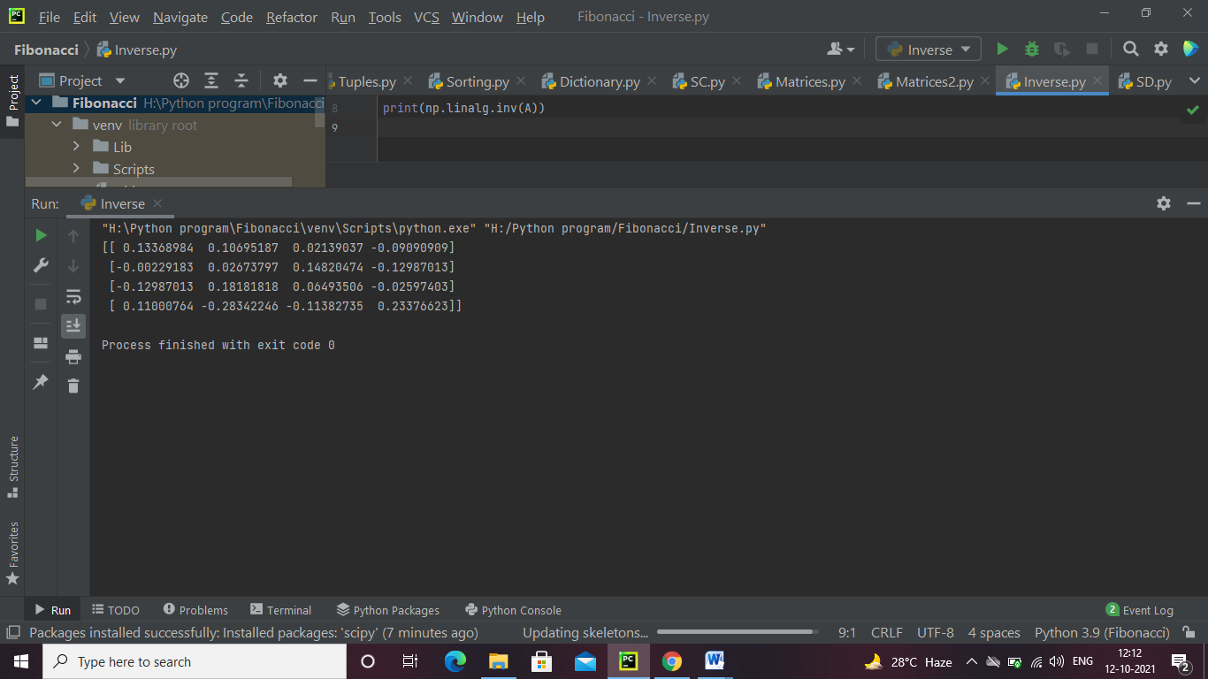

**16. Write a program to calculate the transpose of the given matrix.**

X = [[12, 7],  
 [4, 5],  
 [3, 8]]  
result = [[0, 0, 0],  
 [0, 0, 0]]  
for i in range(len(X)):  
  
 for j in range(len(X[0])):  
 result[j][i] = X[i][j]  
  
for r in result:  
 print(r)

